Proposed Citation for the DOI:
Toure, S.I., D.A. Stow, H. Shih, J. Weeks, and D. Lopez-Carr (2015). Land Cover and Land Use c. 2000 and c. 2010 for Accra, Ghana [Data set]. NASA EOSDIS Land Processes DAAC.

Graphic:

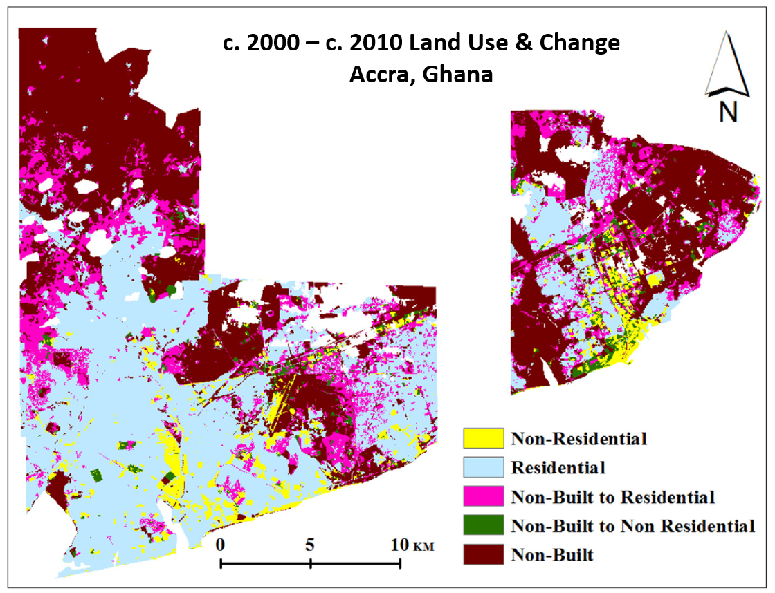

Overview:
The exponential growth of the human population within the last two hundred years has caused important changes in the natural and built environments. The majority of the world's population now lives in urban centers, a shift from the past when people primarily lived in rural areas. Urban centers not only modify the natural environment that they are replacing, they also affect the well-being of the population living within them. Monitoring urban land cover and land use change is therefore important. Remote sensing data of varying spatial resolutions and image change analysis techniques have been used to monitor changes in the urban environment.

The technical objective of the component of our NASA IDS urban study, from which these land cover and land use change (LCLUC) maps were generated, was to test a new bi-temporal change identification approach that integrates image classification of fine spatial resolution satellite imagery at time-2 and moderate spatial resolution satellite imagery (Landsat) at time-1, in a backdating and geographic object-based image analysis (GEOBICA) framework for mapping urban land use change.

Land cover maps and land use maps were created using high spatial resolution, commercial satellite imagery for Accra, Ghana for both c. 2000 and c. 2010. The period was selected as to coincide with the Ghanaian population and housing census. We are interested in knowing the major urban landscape features, and how the physical environment is affected by urban development. Therefore, the major land use types in our classification scheme include residential built (residential for short), non-residential built (non-residential for short), and non-built categories, while the land cover classes that compose land use units are vegetation, impervious and soil. These multi-date products were created in order to assess LCLUC and its effect on demographic and quality of life factors. A land use change map was derived, as shown in the included graphic.

High spatial resolution IKONOS, QuickBird-2, and WorldView-2, and GeoEye-1 satellite images were orthorectified to provide accurate spatial positioning between the multitemporal images. Horizontal ground control points (GCPs) were selected from DigitalGlobe images available in Google Earth. Elevations for GCPs were extracted from NEXTMap World 30, a digital elevation data purchased from Intermap. The GCPs were then incorporated into the orthorectification process, with bi-linear interpolation algorithm and a second-order polynomial refinement of image registration.

Product Details:
•Spatial Coverage: Accra, Ghana

•Temporal Coverage: c. 2000 and c. 2010

•Resolution: 2.4-3.2 m for c. 2000; 1.65-2.4 m for c. 2010

•Projection: UTM Zone 30, WGS 84

•Data Type: Unsigned 8-bit Integer

•Data Format: ERDAS Imagine (.img)

Relevant Literature Utilizing Data Set:
Toure, S.I., D.A. Stow, H. Shih, J. Weeks, and D. Lopez-Carr, 2018. Land cover and land use change analysis using multi-spatial resolution data and object-based image analysis, Remote Sensing of Environment,210: 259-268. DOI: 10.1016/j.rse.2018.03.023

Dataset creator:
Sory Toure
Douglas Stow

Project Information
Project name - The Urban Transition in Ghana and Its Relation to Land Cover and Land Use Change Through Analysis of Multi-Scale and Multi-Temporal Satellite Image Data

Principal Investigator - Douglas Stow

Institution - San Diego State University

