Proposed Citation for the DOI:
Toure, S.I., D.A. Stow, H. Shih, L.L. Coulter, J. Weeks, R. Engstrom, and A. Sandborn (2015). Land Cover and Land Use c. 2000 and c. 2010 for Kumasi, Ghana [Data set]. NASA EOSDIS Land Processes DAAC.

Graphic:
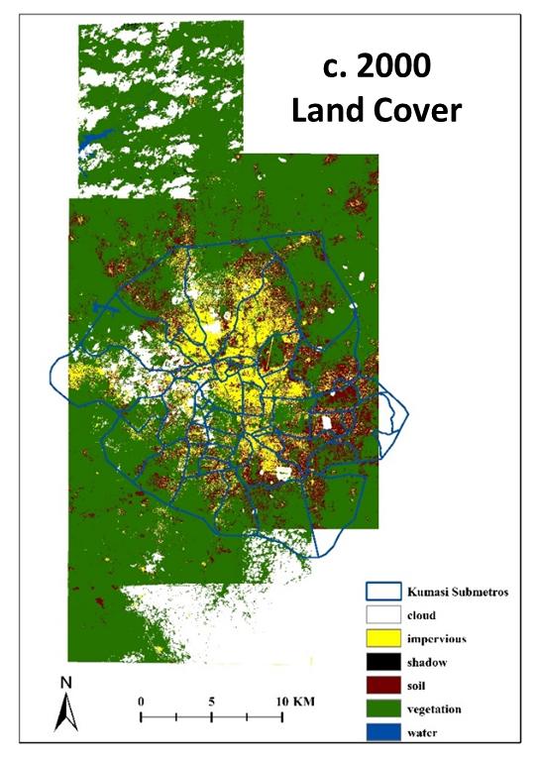
Overview:
The exponential growth of the human population within the last two hundred years has caused important changes in the natural and built environments. The majority of the world's population now lives in urban centers, a shift from the past when people primarily lived in rural areas. Urban centers not only modify the natural environment that they are replacing, they also affect the well-being of the population living within them. Monitoring urban land cover and land use change is therefore important. Remote sensing data of varying spatial resolutions and image change analysis techniques have been used to monitor changes in the urban environment.

Land cover maps and land use maps were created using high spatial resolution, commercial satellite imagery for Kumasi, Ghana for both c. 2000 and c. 2010. The period was selected as to coincide with the Ghanaian population and housing census. The land cover maps include the following classes: vegetation, impervious, soil, water, cloud, and cloud shadow. The land use maps include: residential, non-residential, undeveloped, water, cloud, and cloud shadow. These multi-date products were created in order to assess land cover and land use change (LCLUC) and its effect on demographic and quality of life factors.

The technical objective of the component of our NASA IDS urban study, from which these LCLU/C maps were generated, was to assess the utility of using image segmentation and classification information derived from an object-based classification of an image at a later date (t=2) to aid in the segmentation and classification of an image at an earlier date (t=1) for the same area. High spatial resolution IKONOS and WorldView-2 satellite images were orthorectified in order to provide accurate spatial positioning and precise relative alignment between the multitemporal images. For the orthorectification, horizontal ground control points (GCPs) were selected from accurately positioned DigitalGlobe images available in Google Earth. Vertical ground control was extracted from NEXTMap World 30 digital elevation data purchased from Intermap. A triangulation procedure incorporating the GCPs, using second-order polynomial refinement, and applying bi-linear interpolation was implemented as part of the orthorectification process.

The general image classification workflow consisted of classifying the t=2 image, and then using this product as an aid in classifying the t=1 image. An OBIA approach was adopted using eCognition software. We followed a traditional object-based image classification approach, which has three main steps: segmentation, classification, and generalization. Two maps of differing scale hierarchy were generated for both multispectral images, a finer-scale vegetation-impervious-soil (VIS) map and a coarser-scale land use map. The image object hierarchy in eCognition was used to generate the two maps such that the VIS image objects (Level I) are sub-objects of the land use objects
(Level II).

Product Details:
•Spatial Coverage: Kumasi, Ghana

•Temporal Coverage: c. 2000 and c. 2010

•Resolution: 3.2 m for c. 2000; 1.8 m for c. 2010

•Projection: UTM Zone 30, WGS 84

•Data Type: Unsigned 8-bit Integer

•Data Format: ERDAS Imagine (.img)

Relevant Literature Utilizing Data Set:
Toure, S.I., D.A. Stow, H. Shih, L.L. Coulter, J. Weeks, R. Engstrom, and A. Sandborn, 2016. An object-based, temporal inversion approach to urban land cover and land use change analysis, Remote Sensing Letters, 7 (5): 503-512. DOI: 10.1080/2150704X.2016.1157640

Dataset creator:
Sory Toure
Douglas Stow

Project Information:
Project name: The Urban Transition in Ghana and Its Relation to Land Cover and Land Use Change Through Analysis of Multi-Scale and Multi-Temporal Satellite Image Data

Principal Investigator: Douglas Stow

Institution: San Diego State University

